Game Design: Speak

*The design for this game began on 10/18/2015. It is a game to represent what social anxiety is really like.*

**Premise:** Point and Click Adventure Game following a single day in the life of somebody with social anxiety. Different Choices lead to different paths, events, and endings. The challenge in the game is balancing anxiety levels, stress levels (How many things you need to do), and time. All three of these concepts are interconnected, and each will affect the others.

**Gameplay:** Go through the day, interacting with people, doing your daily tasks, and making decisions. Every action will take a certain amount of time, and most will have an effect on your anxiety and/or stress levels. Sometimes outcomes will depend on previous actions or your current anxiety levels. There will also be small amounts of randomness to account for the fact that you can’t always know whether or not you will freeze or become stressed by an event with anxiety. The goal of the game is to make it through the end of the game is to make it through the end of the day with as little stress and anxiety as possible. The story at the end of the day will depend on your actions and anxiety/stress level. If at any point during the day you max out your anxiety levels you will become overwhelmed and the game will end with a description of what happens afterwards, depending on where you are and your previous actions.

You will be presented with 2D scenes in which you can click on various objects and people to interact with them. Most items and people you interact with will present you with choices to make about how to interact with them. Many interactions, especially ones involving social situations, will be on a timer. If you don’t make a decision by the time the timer is up you will end up with an alternative action “paralyzed/freeze” which represents when someone with anxiety freezes up or panics. This will generally have a large negative effect on your anxiety levels. Most actions will have an effect on your anxiety/stress levels.

**Menu:** The menu will be represented as your phone. Using the menu will also pause the game. There are 5 options on the menu, which are represented as apps on the phone: Status, Agenda, to do list, Contacts, and Tutorial. The current game time will also be shown on the Menu. Depending on the length of the final game there may also be a load/save option. The apps are as follows:

Status: Gives a brief explanation of anxiety and stress levels. Uses words to describe in a more realistic way what the HUD will represent about these levels. Also gives the time until your next activity.

Agenda: Your schedule for the day. Presented as a list with the times of each activity. If you click on the activity as brief description of it will pop up. Every time you finish an activity it gets check marked. If you skip an activity it gets crossed out. Finishing or skipping activities will have an effect on your stress/anxiety levels.

To Do List: Various tasks that need to get job, such as work tasks, chores, and school work. Items may be added throughout the day. When items are finished they are check marked. Finishing items will decrease your stress levels. Adding items will increase your stress levels.

Tutorial: A brief explanation of controls and the game. May include some information about social anxiety.

**Measures:** In the game there will be three measures of your progress: Time, Anxiety, and Stress. Missing events often adds to stress but helps anxiety. Being late to events adds to anxiety. Every few levels of stress either adds a multiplier to anxiety increases, or directly adds to anxiety. It is not always easy to predict the outcomes of actions on your anxiety and stress levels. Some actions may have clear outcomes, others may not.

Anxiety: Your anxiety levels are how anxious you are at any given time. The higher your levels are the more likely you are to have a panic attack or breakdown. It will also become harder to make good decisions the more anxious you are. Your anxiety levels are represented by the presentation of the screen. As your anxiety levels increase a static filter on the screen gets stronger, and it either gets darker or grayer. This is supposed to represent how as anxiety increases it gets harder to perceive what is actually going on and make good choices. When your anxiety levels get really high it also may become harder to understand people or accurately perceive your surroundings. The world responds to your anxiety, as your perception responds to anxiety in real cases.

Stress: Your stress level is defined by how many incomplete items you have on your to do list and how many events you have skipped. Completing events and to do items will decrease your stress levels. Every few levels of stress will either increase your anxiety levels, or add a multiplier to how fast your anxiety levels increase. Stress is represented by a bar on the top of the screen.

Time:Time passes with each action you take. Each event on your agenda starts and ends at a certain time, and being late can cause very large anxiety increases. Be careful to keep track of the time as you progress throughout the day. The time can be checked at any time by looking at your phone. Depending on how difficult it is to keep track of time during gameplay, the time may be added to the HUD.

**HUD:**

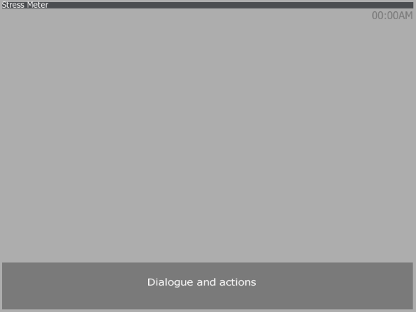

There is a meter describing your stress level at the top of the screen, with the time under it. When there are dialogues or descriptions they will appear in a box at the bottom of the screen.

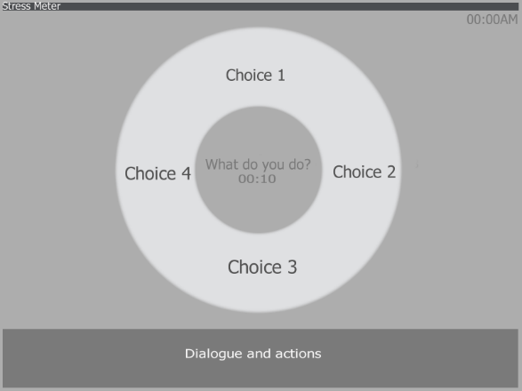

When choices are going to be made a radial menu will appear with the choices that are currently available. The number of choices will vary. There will also be a timer in the middle when the actions are timed. You will click the choice that you choose. The timer will either be in the form of a countdown or a progress bar.

**Starting the Game:** The game starts by asking if you have played before, if not it will provide you with some information on how the game works. After that it will ask for your name and preferred pronouns. These will be used in the game. Then the game will start with your alarm going off in the morning, and you will start your game.

**Setting:** You are a young person with social anxiety in the modern world. You work full time and attend night-time classes. The story will follow a single day in your life. You have the same basic schedule you need to complete, but each play through will vary depending on your choices and some randomness.

**Difficulty:** The game is intended to be fairly difficult to reach the end, and to be stressful/ emotionally difficult to play.

**Purpose:** The purpose of this game is to educate people on social anxiety. This can be used to both help people who suffer from social anxiety to start thinking about good decision making and ways to help ease anxiety, but also as a way for those who do not have anxiety to develop empathy for and understanding of people with social anxiety.

**Audience:** Intended for a more mature audience. Aimed at people interested in learning about social anxiety, or people with social anxiety.